Assignment:

1. Review .umap data file to understand how to parse and use the data for edge detection
2. Research techniques for how to identify rough edges for automatic omission / cleanup
3. Research techniques for how to identify walls and apply a different color - useful for boundary detection for future improvements to the Map Annotator tools
4. Research techniques for identifying and removal of black colored pixel noise
5. Consider using something like Stable Diffusion to beautify the engineering map after the edges and noise have been auto cleaned up
6. Figure out how to build a new image jpg or png from the modified umap raw data
7. if we could generate a new engineering map png with all the walls in red color (any other non-wall obstacle would remain black color) then that would be very useful for other uses

Assignment notes:

1. Edge detection
   1. What is the definition of edge detection?
      1. I would think this would be a corner
         1. What would the typical dimension of corner be?
            1. Scale could be a helpful measurement in this situation
   2. [*step detection*](https://en.wikipedia.org/wiki/Step_detection)
      1. *Finds discontinuities in one dimensional signals*
   3. [*change detection*](https://en.wikipedia.org/wiki/Change_detection)
      1. *Finds signal discontinuities over time*
   4. **Feature detection & feature extraction** are keywords
2. Research techniques to ID rough edges
   1. What are the characteristics of a rough edge?
   2. Automatic omission / cleanup
3. Research techniques to identify walls
   1. What are the Map Annotator tools and where are they currently stored
      1. WHAT
      2. WHERE
4. Research techniques for identifying and removing black colored pixel noise
   1. What are characteristics of the black colored pixel noise?
5. Post auto cleanup, consider how something like Stable Diffusion might be leveraged
   1. Is Stable Diffusion suitable
   2. What are the alternatives
      1. Alternatives
      2. More suitable alternatives
6. Build a new image npg or png from modified umap raw data
   1. JS version (for debugging, I was thinking)
      1. How can we export an image from a canvas into a jpg or png?
         1. <https://stackoverflow.com/questions/923885/capture-html-canvas-as-gif-jpg-png-pdf>
            1. It is possible in js using canvas.toDataURL(“image/png”)
            2. 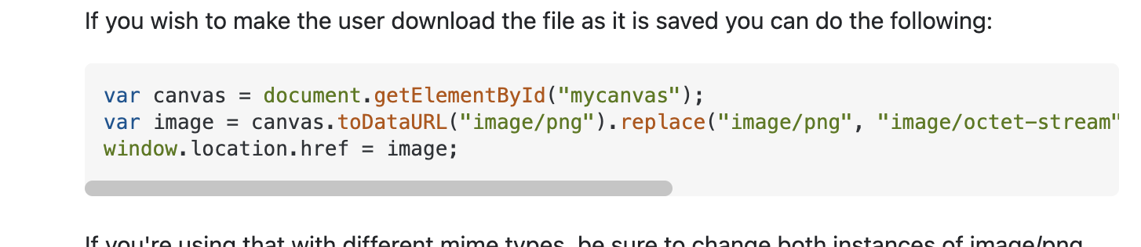
   2. Python version (something similar, translated into python by Austin)
7. Items 3 & 6 will be very useful overall for identifying these walls and turning them RED